Conversion of a 4 bedroom detached house to house an 8 bedroom house with En-Suites.

Project Description:

- A full conversion with a highly comprehensive specification to comply with planning which included but not limited to; a new dual flow heating system, mains wired fire system, full electrical re-wire & testing, Sound Proofing each individual room (walls & ceiling), Pin-code security entry system, New UPVC windows throughout, Garage conversion to useable living space & state of the art remote access CCTV system.

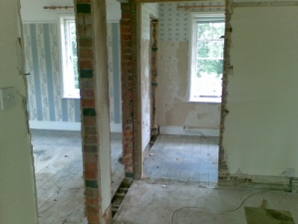
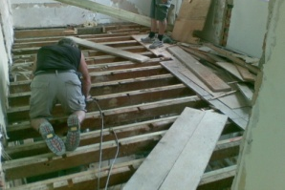
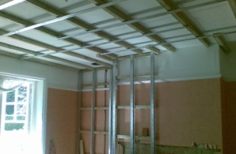
Before
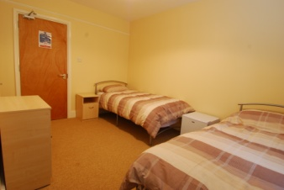
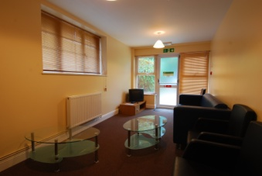
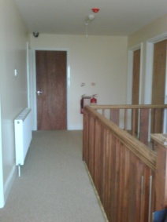
After
Customer Satisfaction

“Planning were very difficult with this development but Seraphim were very supportive & understanding, I could not be happier with the property since the works have been carried out. ”

